**Data Description:**

The data set is a set of petrophysical well logs from a deep offshore gas exploration well, Iago-1, from the Northwest Shelf of Australia. The complete well dataset is publically available in the form of Log ASCII STANARD (.LAS) files at no cost from the publicly available WAPIMS (Western Australian Petroleum and Geothermal Information Management System) database. Six petrophysical measurements were chosen from the well that record changes in density (RHOZ), electrical resistivity (HART), sonic velocity (DTCO), natural radioactivity (ECGR), mean atomic number (PEFZ) and porosity of the rocks penetrated by the well (TNPH). These six logs are typically the most important and commonly acquired petrophysical measurements used in offshore oil and gas exploration wells. In addition, a geological manual domaining is provided. The data set is not perfect as (1) two features were not completely recorded and their logs include missing data and (2) the layer boundaries have been determined manually and need to identify their accuracy and certainties:

**Task 1:** Predict the missing data in these two features. Discuss you results.

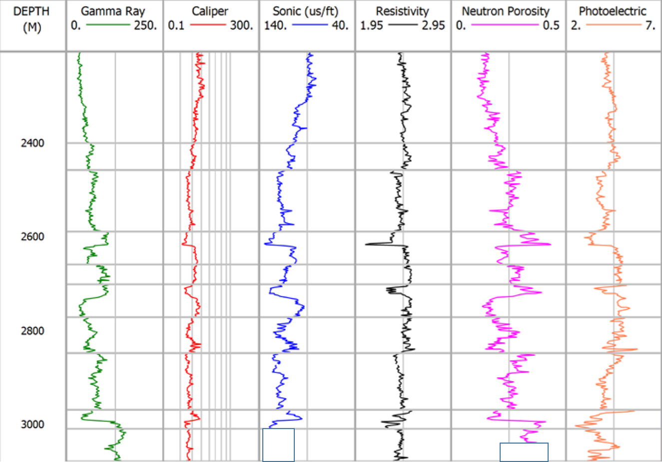

**Task 2:** The geologist decided to dig deeper. Hence, the data has been extended as in the figure below. Missing data are still existing! Predict these missing data in the new extended region: (i) using the trained model of task 1, (ii) training a new model using the new data available. What did you find? Discuss you results.

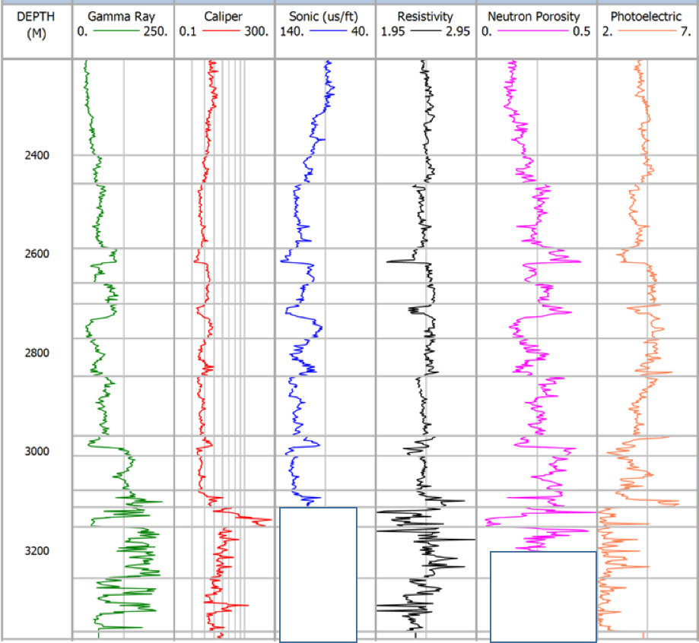

**Task 3:** As mentioned in the description, the geologists have manually identified the domain/layer boundaries. Assess the certainties/accuracy of these geological boundaries: treat each domain as a class label and assess the performance of ML algorithms on this classification task.

